

**Jennifer S. Simonson, OD, FCOVD**

**Boulder Valley Vision Therapy**

2800 Valmont Rd, Boulder, CO 80301

(303) 443-2257 (303) 443-4599 (FAX)

E-Mail: bouldervt@yahoo.com

**www.bouldervt.com**

**Flashlight Activities**

**Purpose:** To organize eye, hand, and body movements in a visually directed way.

**Materials:** Two flashlights

**Procedure:**

1. **Flashlight High 5**: The helper shines a flashlight on the wall. The patient slaps a high five on the light on the wall. Turn light off and move to a new spot. Turn light on and have the patient go High 5.

2. **Flashlight Tag Light Pursuits**: The helper holds a flashlight and moves it in very slow lines, circles, spirals, and figure eight patterns on the wall, floor and ceiling. The patient keep’s their eyes focused on the light.

3. **Flashlight Follow the leader**: Both the home assistant and patient have a flashlight. The assistant shines the light across the wall, ceiling, or floor in slow lines, circles, and patterns. The patient is to keep the light as nearly on the assistant’s light as possible. Move faster if accuracy is high and slower if lagging behind the moving target. Switch roles and chase the patient’s light.

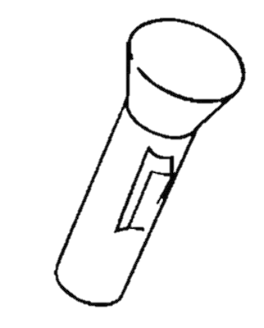4. **Target practice**: Start in a dark room. Patient holds flashlight in off position, arms at sides. Home assistant names an object in the room and the patient aims the flashlight at it and turns it on. See how accurately the light beam can be made to hit the target. Return arms to the sides and choose another object.

**Aspects to emphasize:**

Accuracy of landing the light in the right place or pattern.

