Clarus 500 Retinal Imaging Consent
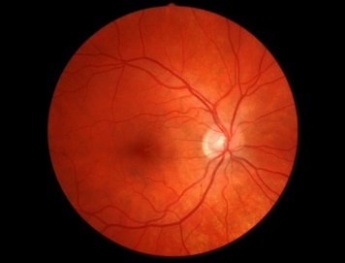
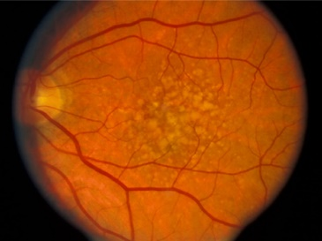

HEALTHY EYE DISEASED EYE

As part of a comprehensive eye exam, it is recommended that ALL patients have the internal health of their eyes thoroughly evaluated every year. This is performed with either a dilated retinal exam or the Clarus 500 retinal imaging.

Conditions such as macular degeneration, tumors, glaucoma, retinal holes, retinal detachments, diabetic retinopathy, and systemic diseases such as diabetes, high cholesterol, and high blood pressure (all of which can lead to loss of vision/blindness) can be detected by the Clarus 500 retinal image.

Benefits of Clarus 500 retinal imaging:
- Provides a digital, three-dimensional, high resolution eye wellness scan
- Gives in depth view of the retinal layers (where disease can start)
- Allows your doctor to review your retinal image with you
- Provides an annual, permanent record for your medical file
- It is fast, easy, and comfortable
- Will NOT require dilating drops which result in blurred vision and sensitivity to light for 3-6 hours

PLEASE NOTE: THERE IS AN ADDITIONAL CHARGE ABOVE THE COMPREHENSIVE EXAM OF $39 FOR THE BASIC CLARUS 500 RETINAL IMAGES WHICH ARE NOT USUALLY COVERED BY INSURANCE. (IN THE CASE OF A MEDICAL DIAGNOSIS, ADDITIONAL IMAGES WILL BE TAKEN, AND CAN BE BILLED TO INSURANCE.)

Please check one of the options below:
  - I have read and understand the above, and agree to the Clarus 500 retinal imaging

  - I have read and understand the above, and wish to discuss the Clarus 500 retinal imaging further

Patient/Guardian Signature: _____________________________________________________Date: ___________________
Print name: ____________________________________________________________

