Grand Strand Vision Services
Vision Development and Vision Rehabilitation
Come see with us, by the sea!
Office Newsletter
November/December 2022
Testing for More than 20/20  20/20 just means that the person can clearly see a certain letter on the standard eye chart (equivalent to what a person with normal vision should be able to see at 20 feet). There’s so much more to healthy vision than 20/20!  Our comprehensive vision exam goes beyond 20/20 to evaluate many important visual skills, such as:  Visual Acuity at Near  Is vision clear and single at close distances?  Eye Teaming Skills  Do the two eyes aim, move, and work as a coordinated team?  Eye Focusing Skills  Do the eyes maintain clear vision at varying distances?  Eye Movement Skills  Do eye movements show adequate muscle control, eye tracking, fixation, etc.?  Reversal Frequency  Is confusion or reversal of letters or words (b, d; p, q; saw, was; etc.) within the normal ranges for a given age?  Above are just a few of the many visual skills evaluated during our comprehensive vision exams for both children and adults, including infants and seniors. In addition, the health of your eyes, inside and out, is carefully evaluated for such problems as cataracts, glaucoma, hypertension, diabetes, etc. |  | 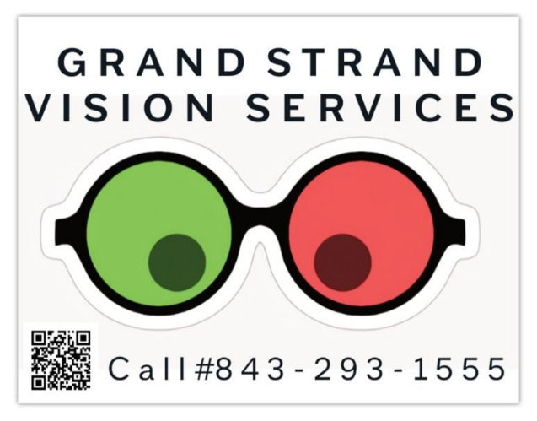  WHAT’S NEW  TAKE A LOOK INSIDE  Come join us in the office this December for a Vision Therapy Workshop! Our workshop will be held at 6pm on December 15th, with Dr. Dean as our keynote speaker.  Holiday Closings  We are excited to celebrate the holiday season with both our patients and our families. We will be closed November 24th and 25th for Thanksgiving, and December 26th-30th for Christmas.  ARE YOU READY TO START?  Join our Vision Therapy Program and gain a whole new perspective of the world of vision and how Vision Therapy can help you. Contact our Vison Therapy Administrator, Heather, at (843)293-1555

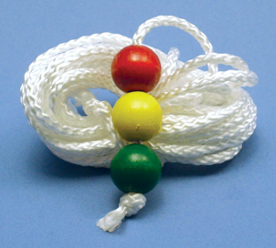
Procedure Highlight  Brock String  The purpose of the Brock String in Vision Therapy is to give you immediate feedback as to whether both eyes are turned on, whether they are pointed to the same place in space, and whether your perception of where a target is matches its real location. Also, to let you become more familiar with how it feels to converge and diverge so that you can gain conscious control of the process.  We use this procedure to train vision development in a variety of patients. Whether you have convergence insufficiency or an eye turn, this little string, and the guidance from your Vision Therapist that comes with it, can make a BIG impact. |  |  | Employee Spotlight  Dr. Mark T. Dean, O.D, FCOVD  Dr. Dean graduated from Illinois College of Optometry in 1976 with his Doctorate in Optometry. Soon thereafter, Dr. Dean began to practice with his father in Sparta Michigan, where he grew up. Dr. Dean relocated to Myrtle Beach in 1981 where he currently owns and directs a specialty practice devoted to Vision Therapy and Vision Rehabilitation.  In his spare time Dr. Dean loves watching a good Western movie, reading up on health and nutrition, and working on his presentations for the seminars that he speaks at.

Joke of the Month
By Adrian King

